

Australian Government
Workforce Australia

Stakeholder Kit

Self-Employment Assistance

Small Business Owners

Last updated: July 2023

Australian Government
Workforce Australia

**Introduction**

Workforce Australia Self-Employment Assistance helps grow or adapt an existing business and provide tools and guidance to re-assess or expand a business.

**Spread the word!**

You have received this stakeholder kit to share information about the Self-Employment Assistance program with small business owners who may benefit from support with their existing business. In this kit you will find a range of promotional resources and information, including social media assets, posters, postcards, website promotion and case studies, to help you promote the free small business support and training services available.

**Promoting on social media**

Social media is a great promotional tool to use as it has the potential to reach and engage a large audience. This includes the ability for your audience to like and share posts with a wider range of people. We encourage you to share the social media assets included in this kit on your own social media networks to help spread the word about how Self-Employment Assistance can help small business owners. Don’t forget to tag us in your social media posts and use these hashtags: #SelfEmploymentAssistance #WorkforceAustralia #AustralianSmallBusiness

[@Workforce Australia](https://www.facebook.com/workforceaustralia?ref=py_c&__xts__%5b%252Ffacebook%5d)

[@SelfEmploymentServices](https://www.facebook.com/SelfEmploymentServices?hc_ref=ARSflNwcIVSYwZUyHKX7hfuA71hesQksk_3TYF2LlY5iAWoVHJquKeiXdj_0kRSaIsc&fref=nf&__xts__%5b0%5d=68.ARB9cVDgRV7utSqQNGefv2nEtZ3hswmeur8AXYOek-EMIctQKK8b71PZ-NZV88uunsLcK4WJU3uxF2EC23HWcySrGeO6-FJF3kHI9urmlKJRemrMWkZEnqCNKJoTe5ZbErHEr5Z6P6-9TaKd2X5DoW8XFzinsfjHF_X8Y9sb3fhSuhVI_KCtT24XvzMd_5IiDfWxi2Q18BdStMjWk9L1eb5391B9z6MgIyeTdRAxiKilV2NCfxcq5kb9iY5byXqtTxiAj81E05GsmE3eZzCqKsxMerg2n9PWJF57so8WJ6vpv8typxIxPbfcqhi7Z4gi3fYeINdcWxZtH7vQlIwASzGi8i8jZuWQ0_ZRiX8_gG_kHit8rSHj4QyE4LmmQYGdJvC4l_dIzaGuAqA8N3eUrKxK)

[@WorkforceAusGov](https://twitter.com/WorkforceAusGov)

@Workforce Australia for Business

## Key messages

The Self-Employment Assistance program is an exciting initiative that provides free support to small business owners with their existing business to grow, improve or adapt to changing economic or labour markets.

Services available include:

* Exploring Self-Employment Workshops
* Business Plan Development
* Small Business Training courses
* Business Advice Sessions
* Business Health Checks
* Small Business Coaching

Self-Employment Assistance is delivered by a network of Self-Employment Assistance providers including expert business coaches and mentors. Find a [Self-Employment Assistance provider](https://www.workforceaustralia.gov.au/individuals/coaching/providers/search?ProviderType=SEA6&GeoLocation.Suburb=null&GeoLocation.State=null&GeoLocation.Postcode=null&GeoLocation.Latitude=null&GeoLocation.Longitude=null&ExactWord=false) near you to discuss your eligibility and options.

**Promotional Products**

The following promotional products are available to promote online or through social media channels. Simply copy and paste the text content to the relevant platform, noting you can tailor the text according to your audience.

***\*The graphics below are visual examples of each promotional product. Please use the high-resolution files saved in the zipped folders attached to this kit for application.***

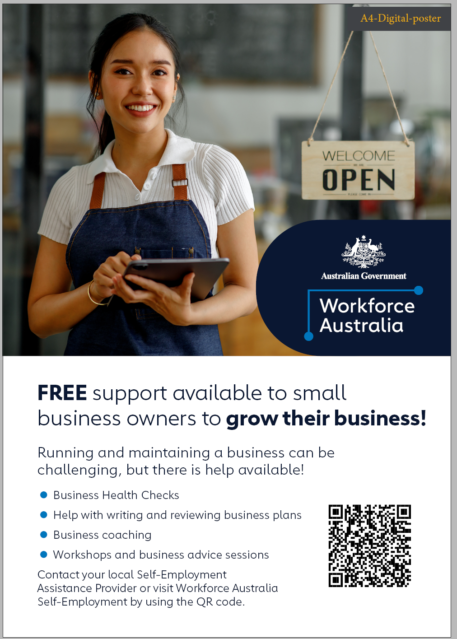**Digital poster**

Digital posters can be used online by displaying on relevant websites or attaching to an email for self-download and printing. Printable versions are also supplied to print at your local printing business.

**Digital postcards**

Digital postcards are a bite-sized version of the digital posters and can also be used online by displaying on relevant websites or attaching to an email for self-download and printing. Printable versions are also supplied to print at your local printing business.

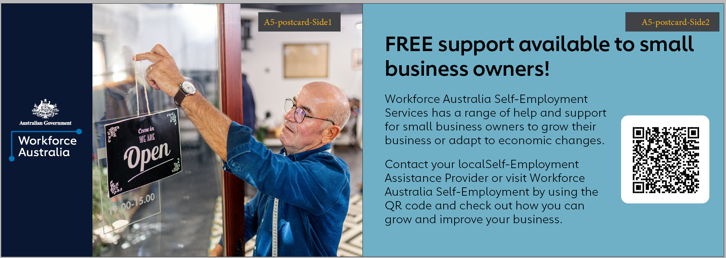

**Website banners**

Website banners are available to apply to websites to help promote Self-Employment Assistance for small business owners. The banners are in standard website specifications.

**Social media**

|  |  |  |
| --- | --- | --- |
| **Channel** | **Content** | **Example social tile** |
| **Twitter**  *NB: 280-character limit.* | Are you a small business owner that wants to get back on track or increase your business? Workforce Australia Self-Employment Assistance offers FREE advice and support. Visit [www.workforceaustralia.gov.au/individuals/training/activities/self-employment-assistance](http://www.workforceaustralia.gov.au/individuals/training/activities/self-employment-assistance) for more info! |  |
| Are you a small business owner struggling to adjust after economic changes? If you want to restart with free help from small business experts, talk to a Self-Employment Assistance Provider today. For more info, visit [www.workforceaustralia.gov.au/individuals/training/activities/self-employment-assistance](http://www.workforceaustralia.gov.au/individuals/training/activities/self-employment-assistance) |
| **Facebook** | Do you want to grow your small business or diversify your products or services? Small business owners can get FREE advice, business planning, training and mentoring through Workforce Australia Self-Employment Assistance.  Get your business and your confidence back on track - talk to a Provider near you today. Visit [www.workforceaustralia.gov.au/individuals/training/activities/self-employment-assistance](http://www.workforceaustralia.gov.au/individuals/training/activities/self-employment-assistance) for more info! |  |
| **LinkedIn** | Are you after advice on how to grow or adapt your business? Or do you know what help you need but don’t know where to find it? Workforce Australia Self-Employment Assistance offers a range of FREE support and advice to small business owners.  From mentoring to workshops, business planning and business health checks - Self-Employment Assistance has you covered.  Visit [www.workforceaustralia.gov.au/individuals/training/activities/self-employment-assistance](http://www.workforceaustralia.gov.au/individuals/training/activities/self-employment-assistance) for more info! |  |
| **Instagram** | Let’s grow your business and kick some business goals this year! Check out Workforce Australia Self-Employment Assistance online for a wide range of FREE support and advice. | |

**Instagram visual examples (post and story graphics):**

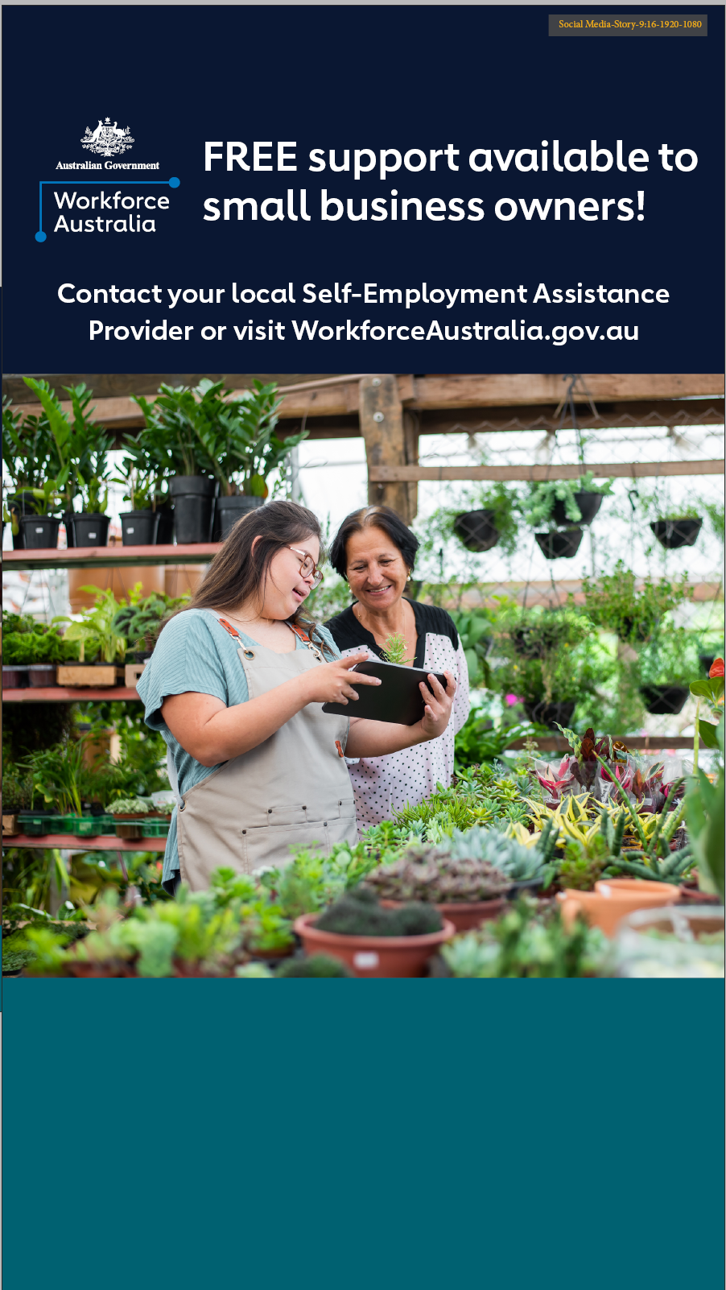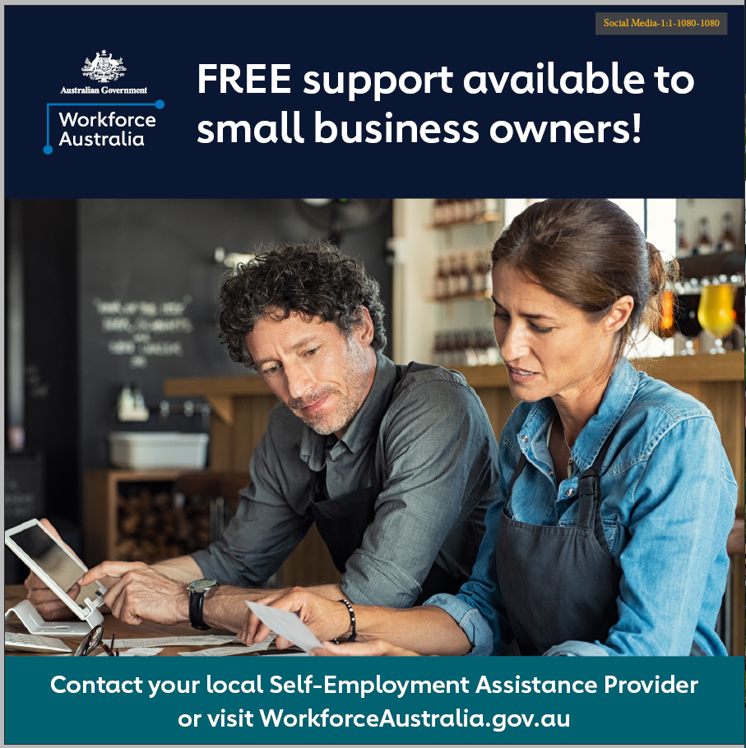

**Website content**

**Do you feel like your business has great potential but you could use some help?**

Running a business can be hard work! But did you know free support is available? Workforce Australia Self-Employment Assistance offers a wide range of FREE support and advice to business owners. This includes mentoring, reviewing business and financial plans, business health checks, workshops, small business training and networking opportunities.

If you feel like your business needs streamlining; or you’re recovering from the effects of the pandemic or changing economic and labour market conditions, see how Self-Employment Assistance can help you grow your business.

Visit [www.workforceaustralia.gov.au/individuals/training/activities/self-employment-assistance](http://www.workforceaustralia.gov.au/individuals/training/activities/self-employment-assistance) for more information.

**Newsletter content**

**Are you a small business owner needing advice on how you can grow and maintain your business?**

The Australian Government provides FREE support to help you adapt or grow your existing small business, through Workforce Australia Self-Employment Assistance.

Self-Employment Assistance provides:

* Exploring Self-Employment Workshops
* Business Plan Development
* Small Business Training courses
* Business Advice Sessions
* Business Health Checks
* Small Business Coaching.

Self-Employment Assistance program is funded by the Department of Employment and Workplace Relations.

You can learn more about Self-Employment Assistance at: <https://www.workforceaustralia.gov.au/individuals/training/activities/self-employment-assistance>

You can also phone 1800 805 260 or ask your Workforce Australia Provider to refer you to the program.

# Frequently Asked Questions

# What if my audience live in different states and territories across Australia?

The information provided in this pack is applicable across Australia.

#### Can I modify the suggested posts and example articles contained in the toolkit?

Yes. The sample posts and articles provided in this pack are provided as a guide only, please feel free to edit and tailor to your audience.

#### I would like a different type of promotional product not included in this Stakeholder Kit. Am I able to request it to be made?

If you require a promotional item that is not included in this Stakeholder Kit or in the generic [Workforce Australia Self-Employment Assistance Stakeholder Kit](mailto:Workforce%20Australia%20Self-Employment%20Assistance%20Stakeholder%20Kit), email [communication@dewr.gov.au](mailto:communication@dewr.gov.au) with your requirements.

# Contact

For more information, or additional content you might like to use on your communication channels, please email [communication@dewr.gov.au](mailto:communication@dewr.gov.au).